**DAY 4**

1)

How to compare two JSON have the same properties without order?

var obj1 = { name: "Person 1", age:5 };

var obj2 = { age:5, name: "Person 1" };

**ANSWER:**

var obj1 = { name: "Person 1", age:5 };

var obj2 = { age:5, name: "Person 1" };

// to compare the objects to check both are equal or not

var flag=true;

if(Object.keys(obj1).length==Object.keys(obj2).length){

for(key in obj1) {

if(obj1[key] == obj2[key]) {

continue;

}

else {

flag=false;

break;

}

}

}

else {

flag=false;

}

console.log("is object equal"+flag);

**OUTPUT:**

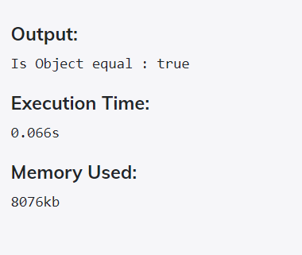

2)

Use the rest countries API url -><https://restcountries.eu/rest/v2/all> and display all the country flags in console

**ANSWER:**

<!DOCTYPE html>

<html>

<body >

<script>

fetch('https://restcountries.eu/rest/v2/all')

.then(res => res.json())

.then(data =>{

for(let i in data)

{

var img2 = document.createElement('img'); // Use DOM HTMLImageElement

img2.src = data[i]["flag"];

img2.alt = 'alt text';

img2.style.width = "200px";

img2.style.height = "200px";

document.body.appendChild(img2);

// using first image in the document

console.log(document.images[0].src);

}

});

</script>

</body>

</html>

**OUTPUT:**

I host the code in the netlify application. Here is the link [https://blissful-yalow-5a6e95.netlify.app](https://blissful-yalow-5a6e95.netlify.app/)

* This link will display all the flags in the api

3)

Use the same rest countries and print all countries name, region, sub region and population

**ANSWER**

<!DOCTYPE html>

<html>

<body >

<script>

fetch('https://restcountries.eu/rest/v2/all')

.then(res => res.json())

.then(data =>{

for(i in data)

{

console.log("Country Name : " + data[i]["name"] +" , "+ " Region : " + data[i]["region"] + " , " + "Subregion : " + data[i]["subregion"] + " , " + "Poupulation : " + data[i]["population"]);

}

});

</script>

</body>

</html>

**OUTPUT:**

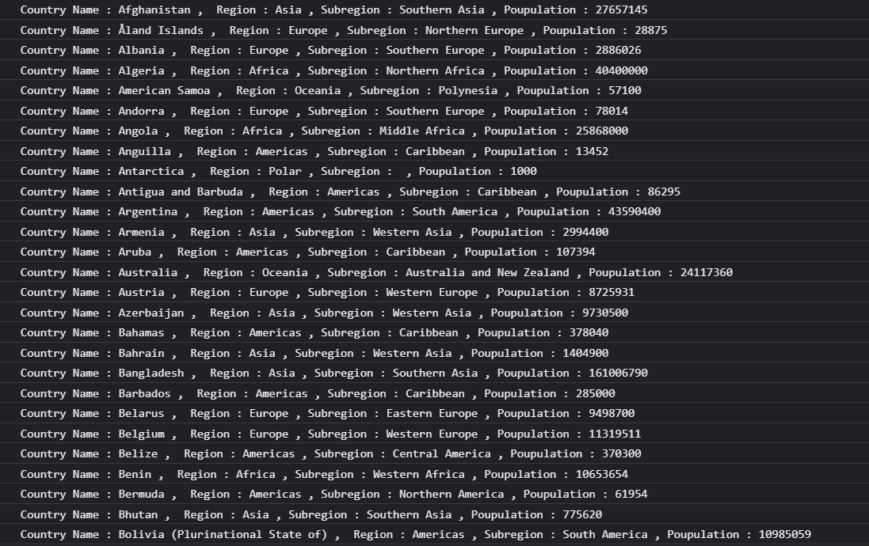

4)

https://medium.com/@reach2arunprakash/www-guvi-io-zen-d395deec1373

**Task 1: Simple Programs todo for variables**

1. Declare four variables without assigning values and print them in console

**ANSWER**

let a;

let b;

let c;

let d;

console.log(a);

console.log(b);

console.log(c);

console.log(d);

**OUTPUT**

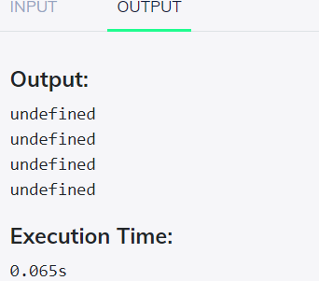

1. How to get value of the variable myvar as output

var myvar= 1;  
console.log("myvar");

**ANSWER**

var myvar= 1;

console.log(myvar);

**OUTPUT**

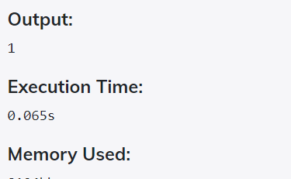

1. Declare variables to store your first name, last name, marital status, country and age in multiple lines

**ANSWER**

let first_name = "Elakkiya";

let last_name = "Elangoraja";

let marital_status = "Single";

let country = "India";

let age = 21;

console.log("first_name: " + first_name +"\n" + "last_name:"+last_name+"\n"+"marital_status: "+marital_status+"\n"+"country: "+country+"\n"+"age: "+age);

**OUTPUT**

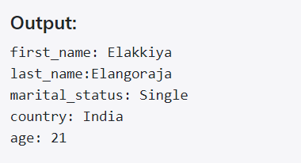

1. Declare variables to store your first name, last name, marital status, country and age in a single line

**ANSWER**

let first_name = "Elakkiya";

let last_name = "Elangoraja";

let marital_status = "Single";

let country = "India";

let age = 21;

console.log("first_name: " + first_name +"," + "last_name:"+last_name+","+"marital_status: "+marital_status+","+"country: "+country+","+"age: "+age);

**OUTPUT**

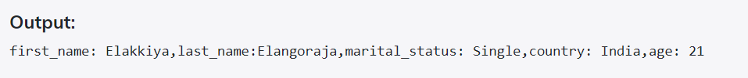

5. Declare variables and assign string, boolean, undefined and null data types

I am 25 years old. You are 30 years old.

**ANSWER**

let string_value = "I am 25 years old";

let boolean_value = true;

let undefined_value;

let null_value=null;

console.log(string_value);

console.log(boolean_value);

console.log(undefined_value);

console.log(null_value);

**OUTPUT**

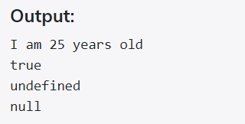

6. Convert the string to integer

* parseInt()
* Number()
* Plus sign(+)

**ANSWER**

let string_value ="5";

console.log(typeof(parseInt(string_value)));//using parseInt

console.log(typeof(Number(string_value)));//using Number

console.log(typeof(+string_value));//using + operator

**OUTPUT**

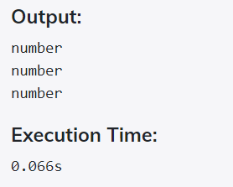

— — — — — — — — — — — — — — — — — — — — — — — — -

# Task 2: Simple Programs todo for Operators

1. Square of a number

**ANSWER**

let num = 5;

console.log("Square of a number : " +(num * num));

**OUTPUT**

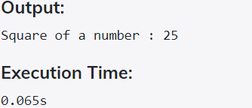

1. Swapping 2 numbers

**ANSWER**

let num1 = 5;

let num2 = 10;

let temp; //create temporary variable

temp = num1; //store num1 in temp

num1 = num2; //replace num1 value with num2

num2 = temp; //assign num2 value with temp ot contains num1 value

console.log("Num1:"+num1);

console.log("Num2:"+num2);

**OUTPUT**

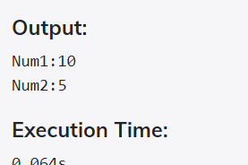

1. Addition of 3 numbers

**ANSWER**

let num1 = 5;

let num2 = 10;

let num3 = 15;

console.log("Addition of 3 numbers : "+(num1+num2+num3));

**OUTPUT**

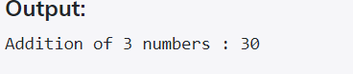

1. Celsius to Fahrenheit conversion

**ANSWER**

let celsius = 55;

// calculate fahrenheit

const fahrenheit = (celsius * 1.8) + 32

console.log(`${celsius} degree celsius is equal to ${fahrenheit} degree fahrenheit.`);

**OUTPUT**

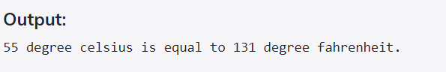

1. Meter to miles

**ANSWER**

let meter_value = 100;

const mile_value = 1609.344;

console.log("converted value : "+(meter_value/mile_value));

**OUTPUT**

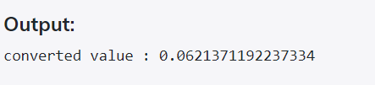

1. Pounds to kg

**ANSWER**

let pounds_value = 3;

const val = 2.2046;

console.log("Converted value : "+ (pounds_value/val));

**OUTPUT**

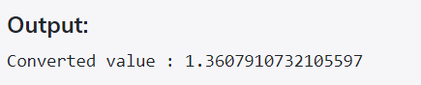

1. Calculate Simple Interest

**ANSWER**

let p,r,t,si;

p=34000,r=30,t=5;

si=(p*r*t)/100;

console.log("simple intrest : ",si)

**OUTPUT**

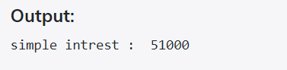

1. Volume Of Sphere

**ANSWER**

let radius=5;

let volume = (4/3)* Math.PI * Math.pow(radius, 3);

console.log(volume.toFixed(2));

**OUTPUT**

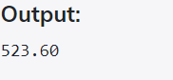

1. Volume Of Prism

**ANSWER**

let l = 18, b = 12, h = 9; //length,breadth,height

let volume = (l * b * h) / 2;

console.log(volume);

**OUTPUT**

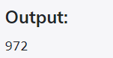

1. Find area of a triangle.

ANSWER

const baseValue = prompt('Enter the base of a triangle: ');

const heightValue = prompt('Enter the height of a triangle: ');

// calculate the area

const areaValue = (baseValue * heightValue) / 2;

console.log( `The area of the triangle is ${areaValue}`);

OUTPUT

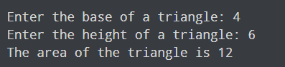

1. Given two numbers and perform all arithmetic operations.

ANSWER

let a=10;

let b=5;

console.log('The sum of 2 numbers is ' + (a+b));

console.log('The subtraction of 2 numbers is ' + (a-b));

console.log('The multiplication of 2 numbers is ' + (a*b));

console.log('The division of 2 numbers is ' + (a/b));

console.log('The modulo of 2 numbers is ' + (a%b));

OUTPUT

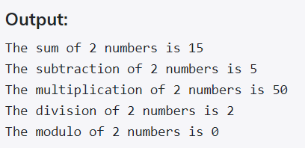

1. Display the asterisk pattern as shown below(No loop needed):  
   *****  
   *****  
   *****  
   *****  
   *****

ANSWER

let n = 5; // row or column count

// defining an empty string

let string = "";

for(let i = 0; i < n; i++) { // external loop

for(let j = 0; j < n; j++) { // internal loop

string += "*";

}

// newline after each row

string += "\n";

}

// printing the string

console.log(string);

OUTPUT

